DSA4213 Assignment 1 Report: Language Models, Embeddings and Representations on Little Women

1. Introduction
On a small single-author corpus (Little Women, ~184k training tokens), the LSTM gave the best next-token prediction (test perplexity 106.2), while the larger Transformer overfit within 9 epochs and was beaten by a Kneser-Ney trigram. This report investigates: does better next-token prediction on Alcott lead to representations that better recognise Alcott's writing?
- Part I compares four language models (KN trigram, RNN, LSTM, Transformer) under a shared setup.
- Part II holds the LSTM fixed and varies input embeddings (random-trainable, own Skip-gram frozen, GloVe frozen) to isolate trainability versus extra pretraining data.
- Part III evaluates frozen representations on passage classification between Alcott (Little Men) and Austen (Pride and Prejudice).

2. Data and preprocessing
The corpus is Little Women (Louisa May Alcott, Project Gutenberg #514), split by chapter to avoid sentence-level leakage.
- Cleaning: Removed Gutenberg licence sections and split text into 47 chapters (dropping fragments < 500 words).
- Split: Interleaved chapter-level split: every 10th chapter to test, the preceding chapter to validation, and remainder to train.
- Normalisation: Lowercased, standardized quotes, stripped italic markers, and preserved contractions and basic punctuation.
- Vocabulary: Built from training split only (minimum frequency 2, mapping rare words to <unk>).
Statistic | Train | Validation | Test
Chapters | 39 | 4 | 4
Tokens | 184,072 | 23,355 | 14,905
<unk> rate | 2.38% | 4.58% | 5.78%
The vocabulary contains 5,641 types (from 10,013 unique words). Higher test <unk> rates reflect unseen vocabulary in evaluation splits.

3. Part I: Language model comparison
LSTM achieved the lowest test perplexity (106.2), followed by RNN (115.0), KN trigram (132.6), and Transformer (143.6).

3.1 Setup
Neural LMs share 100-d trainable embeddings, 64-token context, AdamW (lr 1e-3, batch 32, dropout 0.3, seed 42). Early stopping with patience 3 was used. RNN/LSTM: 2 layers, hidden 256. Transformer: 2 pre-norm layers, d_model 256, 4 heads. KN trigram discount D=0.9 was tuned on validation.

3.2 Results
Model | Test CE (nats) | Test PPL | Size | Train time (s) | Best / run epochs | Inference (tok/s) | Hardware
LSTM | 4.665 | 106.2 | 2,906,765 params | 61.5 | 43 / 46 | 561,328 | Tesla T4
RNN | 4.745 | 115.0 | 2,237,069 params | 21.6 | 21 / 24 | 678,981 | Tesla T4
KN trigram | 4.887 | 132.6 | 202,300 counts | 0.6 | - | 239,643 | CPU
Transformer | 4.967 | 143.6 | 3,110,797 params | 16.7 | 9 / 12 | 506,394 | Tesla T4
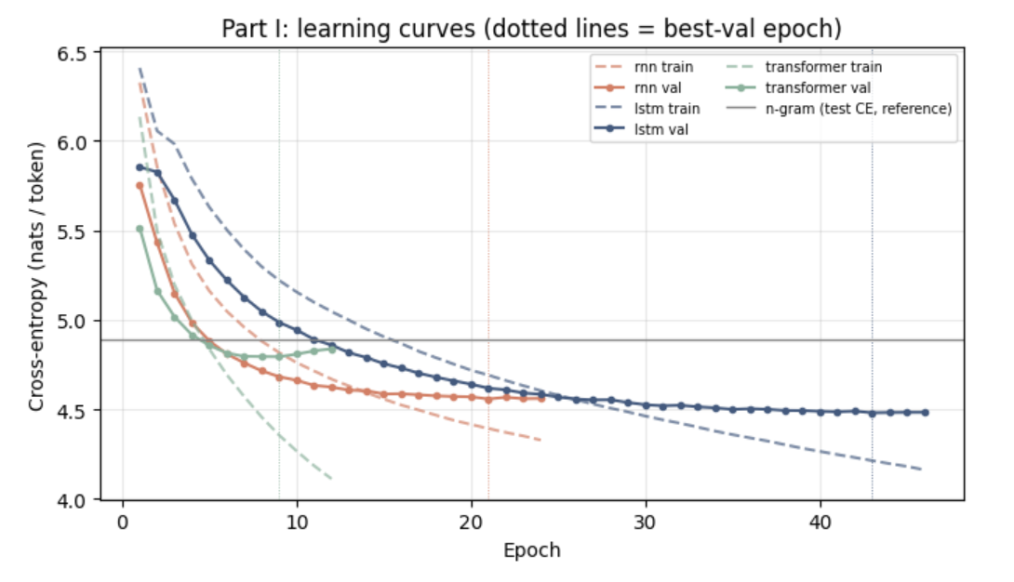
Figure 1: training (dashed) and validation (solid) loss per epoch

3.3 Observations
- Overfitting: Transformer overfit early at epoch 5; RNN at 14; LSTM at 26.
- Convergence: LSTM started slow but improved steadily until epoch 43.
- Size vs Quality: Parameter ranking was inverse to perplexity ranking; KN trigram beat the Transformer.
- Train vs Val: Initial train loss was higher than val loss due to active dropout in training.
- Throughput: GPU throughput mirrored model complexity (RNN > LSTM > Transformer).

3.4 Generated text
Trigram repeats phrases due to 2-word context limit. Neural LMs captured dialogue structures without exact text memorisation (Appendix D).

3.5 Interpretation (hypotheses)
- Context window: Neural models leverage up to 64 tokens vs 2 for trigram, explaining lower perplexity.
- LSTM Gating: Prevents vanishing gradients, aiding long-range context better than vanilla RNN.
- Data Scale: Transformer lacks strong inductive biases, leading to quick overfitting on ~184k tokens.

4. Part II: Embedding variants and ablation
Trainable random embeddings yielded the best test PPL (106.2), frozen GloVe ranked second (115.1), and frozen corpus-trained Skip-gram came last (128.5).

4.1 Design
Using the Part I LSTM, initial weights are kept identical across runs; only the embedding table varies.
Setting | Embedding table | Source of vectors | Embedding cost
A. Random | trainable | random initialisation (Part I LSTM) | none; learned during training
B. Own SGNS | frozen | Skip-gram with negative sampling (Little Women train split) | 26.7s on Tesla T4 (30 epochs)
C. GloVe | frozen | GloVe 6B-100d (~6B tokens) | pretrained externally
- A vs B: Isolates trainability under identical source data.
- B vs C: Isolates external pretraining scale under frozen settings.
- Bit-identical checks confirmed frozen tables remained un-updated.
GloVe covered 98.7% of vocabulary types. 72 missing words (mostly names/archaic terms) were initialized randomly at GloVe's scale.

4.3 Observations
- Trainability Effect: Trainable embeddings outperformed frozen corpus-trained ones by 22.3 PPL points (106.2 vs 128.5).
- Pretraining Data Effect: GloVe beat corpus SGNS by 13.4 points (115.1 vs 128.5), but trailed trainable random embeddings.
- Convergence: Frozen variants took ~40% longer to converge despite having fewer trainable parameters.
- Neighbour Properties: Corpus SGNS vectors reflect dialogue punctuation patterns; GloVe vectors encode standard semantic relations.

4.4 Interpretation (hypotheses)
- Adaptation: Trainable parameters optimize directly for LM task objectives.
- GloVe Scale: External training data stabilizes representations for low-frequency words.
- Dialogue Bias: Small-corpus SGNS over-indexes on co-occurring punctuation/quotation context.
- Compute Cost: Random embedding cost is integrated into LM training; GloVe offloads computation externally.

5. Part III: Downstream representation analysis
Mean pooling dominated model choice: mean-pooled features hit 83–88% test accuracy vs 60–69% for final states. LM perplexity did not predict downstream accuracy (Spearman ρ = -0.20).

5.1 Task and data
Task: Authorship attribution on unseen books: Alcott (Little Men) vs Austen (Pride and Prejudice).
- Cleaning: Stripped prefaces, image captions, and chapter titles to prevent lexical shortcutting.
- Passages: Packed full sentences into 20–64 token passages using the Part I preprocessing pipeline.
- Split: Block-partitioned split (20-passage blocks) downsampled to 50/50 class balance.
Split | Passages/class | Mean length | <unk> rate (Alcott/Austen)
Train | 1,993 | 50.1/52.0 | 6.3%/8.6%
Validation | 240 | 51.2/52.1 | 5.7%/8.7%
Test | 240 | 50.8/51.8 | 6.9%/8.2%

5.2 Representations and classifier
Passages pass through frozen LMs. Top-layer hidden states (256-d) are extracted via:
- Mean pooling: Average hidden state across real tokens (padding masked).
- Final state: Hidden state at the final non-padding token.
Classifiers use standardized logistic regression (C tuned on validation). Metrics report test accuracy with 95% bootstrap CI (1,000 resamples).
Comparisons evaluate LSTM vs Transformer alongside baseline models (<unk> rate and TF-IDF).
Table 7: Part III test accuracy by representation (frozen LMs, logistic regression, C tuned on val; 95% bootstrap CI).
Representation | LM test PPL | Mean pooling | Final state
LSTM | 106.2 | 0.850 [0.821, 0.881] | 0.671 [0.627, 0.713]
RNN | 115.0 | 0.848 [0.812, 0.881] | 0.602 [0.560, 0.648]
LSTM + GloVe (frozen) | 115.1 | 0.875 [0.846, 0.904] | 0.692 [0.648, 0.731]
LSTM + own SGNS (frozen) | 128.5 | 0.873 [0.842, 0.900] | 0.677 [0.635, 0.719]
Transformer | 143.6 | 0.829 [0.792, 0.863] | 0.675 [0.633, 0.719]
Bag-of-words TF-IDF (no LM) | - | 0.971 [0.954, 0.985] | -
<unk> rate only (no LM) | - | 0.569 [0.525, 0.608] | -
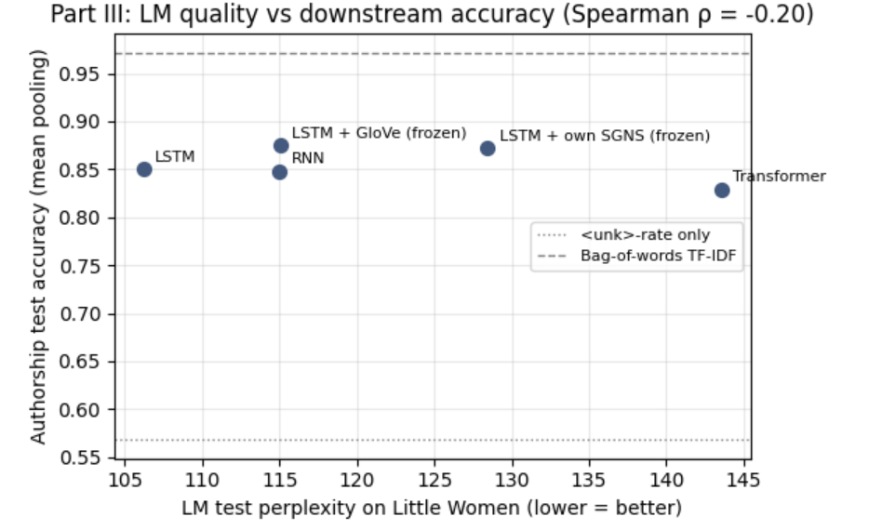
Figure 3: LM test PPL vs authorship test accuracy (mean pooling). Spearman ρ = −0.20.

5.4 Error analysis
Mean-pooled LSTM made 72 errors vs 82 for Transformer (32 overlapping). Misclassifications stemmed from opposing stylistic traits rather than sequence length or <unk> frequency:
- Formal Alcott: Elevated narration in Alcott triggered Austen predictions.
- Informal Austen: Casual dialogue in Austen triggered Alcott predictions.
- Name Overlap: Shared character names (e.g. Elizabeth / Beth) misdirected predictions.
TF-IDF leveraged key proper nouns (bhaer, jo vs elizabeth, darcy) and function word distribution differences.

5.5 Interpretation (hypotheses)
- Pooling Strategy: Mean pooling outperformed final-state pooling for every model (Table 7). This suggests that authorship attribution depends on stylistic signals distributed throughout a passage, such as function-word usage, punctuation patterns, and recurring grammatical structures. Mean pooling aggregates these signals across the passage, whereas the final hidden state may place greater emphasis on the ending tokens and the sequential information retained at the end of the passage. The experiments do not establish which individual stylistic features contribute most to the improvement.
- Language Modelling vs Downstream Performance: Lower language model perplexity did not translate directly into better authorship classification. Although the LSTM achieved the lowest test perplexity (106.2), its mean-pooled representation achieved 85.0% test accuracy, below the frozen GloVe and own-SGNS variants at 87.5% and 87.3%, respectively, but these differences fall within overlapping confidence intervals. The Spearman correlation between language model perplexity and mean-pooled authorship accuracy was weakly negative (ρ = - 0.20, n = 5, p = 0.75), providing little evidence of a consistent relationship in these experiments. This is plausible because next-token prediction optimises representations for predicting upcoming words, whereas authorship attribution requires distinguishing stylistic patterns between writers.
- Dense Representations vs Lexical Baselines: TF-IDF achieved 97.1% test accuracy, substantially exceeding the 82.9 to 87.5% range of mean-pooled neural representations. This suggests that explicit lexical information is highly discriminative for the two books, potentially through differences in word frequencies, function words, and author- or character-specific vocabulary. In contrast, mean pooling compresses a sequence of contextual hidden states into a fixed 256-dimensional vector, which may not preserve every discriminative lexical distinction. However, TF-IDF’s high accuracy does not establish that it has learned generalisable authorial style: it may also exploit book-specific vocabulary and proper nouns. It shows that lexical differences separate these two books well, not that TF-IDF is generally superior for authorship attribution.

6. Discussion, limitations and lessons
Stronger sequential priors and trainable embeddings predicted text best on small data, but LM perplexity did not transfer to better authorship classification.

6.1 Connecting the three parts
- Part I → Part II: Trainable embeddings adapt directly; freezing them hurts PPL significantly on small corpora.
- Part I/II → Part III: Perplexity rank did not predict authorship accuracy (Spearman ρ = −0.20).
- Small Data Bottleneck: Overfitting and vocabulary gaps directly stem from restricted training volume.

6.2 Limitations
- Single seed: Results may vary across seed initialisations.
- No HPO: Models used fixed defaults without hyperparameter sweeps.
- Parameter counts: Model scales ranged from 2.2M to 3.1M parameters.
- Single prompt samples: Qualitative evaluation relies on limited text outputs.
- Corpus scope: Findings reflect a single-author training domain.
- Lexical shortcuts: Proper nouns drive strong baseline separation.
- Hardware differences: CPU trigram execution speed is not directly comparable to GPU runs.

6.3 Lessons learned
- Convergence Checks: Extended epoch bounds are necessary to verify true stopping points.
- Grid Validation: Hyperparameter boundaries must be expanded past edge optima.
- Hardware Consistency: Benchmarking requires uniform compute hardware.

7. References
- Alcott, L. M. Little Women; Little Men. Austen, J. Pride and Prejudice. Project Gutenberg eBooks #514, #2788, #1342.
- Kneser, R. & Ney, H. (1995). Improved backing-off for M-gram language modeling. ICASSP.
- Mikolov, T. et al. (2013). Distributed representations of words and phrases and their compositionality. NeurIPS.
- Pennington, J., Socher, R. & Manning, C. (2014). GloVe: Global vectors for word representation. EMNLP.
- PyTorch; scikit-learn (Pedregosa et al., 2011).

Appendix A: Design decisions and rationale
Decision | Why
Interleaved chapter-level split | A random sentence split leaks context between neighbouring sentences; interleaving represents both halves of the book
Vocabulary from train only, min frequency 2 | Building it on test would leak information; singletons are too sparse to learn
Shared config, seed and early-stopping rule for all neural LMs | Differences can then be attributed to the architecture
Same test targets, padding excluded | Perplexities are comparable only over identical tokens
KN discount tuned on validation; grid extended at its edge | Avoids test leakage; an edge optimum may not be the true optimum
Epoch cap raised to 150 | Models cut off while improving are not compared fairly; all now stop by early stopping
Same seed for all Part II settings | Only the embedding table differs, isolating its effect
SGNS extended from 5 to 30 epochs | The loss was still falling and the neighbours were collocations, showing undertraining
GloVe contractions composed from their parts | GloVe splits contractions; the corpus is dialogue-heavy
Authorship task on books unseen by the LMs | No leakage, exact labels, and it ties to Parts I–II
Saintsbury preface and illustration tags removed | Not Austen's writing, and a lexical shortcut, respectively
Block split and 50/50 balance in Part III | Prevents near-duplicate leakage; keeps accuracy meaningful
Mean vs final-state pooling, padding masked | Two ways of summarising a passage; padding would distort both
<unk>-rate and bag-of-words baselines | Shows how much is solvable by shortcuts
Bootstrap confidence intervals | Avoids over-reading small differences

Appendix B: Reproducibility and full configuration
Code: [TBC: GitHub link]. Run the notebooks in order in Google Colab on a Tesla T4 GPU (PyTorch 2.x, scikit-learn), with seed 42 throughout:
- data_preparation.ipynb: downloads the books from Project Gutenberg by ID (514, 2788, 1342), cleans them and builds the split and vocabulary.
- part1_language model training.ipynb: KN trigram, RNN, LSTM, Transformer; writes the shared lm_utils.py.
- part2_embeddings.ipynb: SGNS training, GloVe download (6B-100d), and the frozen-embedding LSTMs.
- part3_downstream representation analysis.ipynb: passage dataset, feature extraction, classifiers and error analysis.
No book text or GloVe file is committed to the repository; both are downloaded by the code. All configurations are in each notebook's CFG cell and in the README.

Appendix C: AI tool use statement
I designed and carried out the experiments in this report with help from an AI coding assistant (Claude, Anthropic). I chose the corpus (Little Women), worked on the experimental set up and the Part III authorship task, ran every experiment in Google Colab, checked each output, and wrote the analysis and interpretation. Every number reported comes from my own runs.
The assistant worked on generating suggested improvements and refined the code across the four notebooks and the shared module lm_utils.py, covering data preparation, the language models, training and evaluation, the embedding variants and the Part III classifier. It also flags errors when results looked wrong. Working through these issues with it, I resolved several problems that affected the fairness of the comparisons: training initially running on CPU, models stopping at the epoch cap before converging, the n-gram discount being selected at the edge of its search range, and undertrained Skip-gram embeddings. I have read the code and can explain the purpose of each component and design decision (Appendix A).

Appendix D: Supplementary results

Setting | Test PPL | Best val PPL | Best / run epochs | Epochs to val PPL < 120 | LM train time (s) | Trainable params | Epochs where val got worse
A. Random (trainable) | 106.2 | 88.3 | 43 / 46 | 15 | 57.2 | 2,906,765 | 7
B. Own SGNS (frozen) | 128.5 | 107.1 | 65/68 | 40 | 84.6 | 2,342,665 | 4
C. GloVe (frozen) | 115.1 | 95.7 | 58/61 | 23 | 79.9 | 2,342,665 | 4
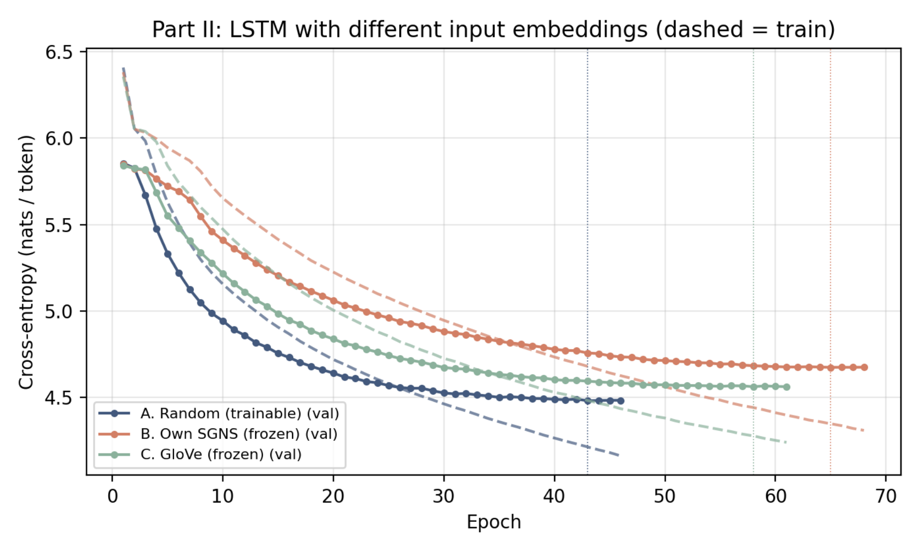Figure 2: LSTM with different input embeddings
Table D1: Nearest neighbours by cosine similarity, own SGNS vs GloVe embeddings.

Word | Own SGNS (Little Women) | GloVe (general English)
jo | said, “, ,, ., amy, and | jo’s, amy, ellen, mary, annie, fred
laurie | jo, ,, said, ., “, ? | laurie’s, kate, ellen, peck, amy, parker
christmas | bloomed, regularly, merry, chrysanthemums, recesses, greeting | holiday, eve, holidays, wedding, day, birthday
mother | father, “, you, ?, to, be | daughter, wife, grandmother, father, sister, mother’s
said | jo, “, ., ,, laurie, amy | told, says, saying, added, asked, ,

Table D2: Generated text, Part I models (40 tokens, temperature 0.8, top-k 40, seed 42)
Prompt | Model | Generated continuation
jo laughed and said | Trigram | , “ returned amy, as the old fashioned pearls long for your own. a little girl, and i’m all, the girls were all her that she would, and amy were out of my things,
 | RNN | , as she had no more than ever. “ here’s the old lady, and then it wasn’t more than i can have a nice thing? “ “ and, i suppose you’d do you? “ said
 | LSTM | , as she had got a pair of the family and amy in the middle of his own. “ i’m all, it’s a nice thing? “ “ i, dear, “ said amy, wondering that
 | Transformer | her little, and amy began the story. “ “ amy, “ said meg, who liked the instrument. “ “ “ added meg? “ “ and, wondering amy, who took my word,
it was a cold winter morning and | Trigram | be very kind, and the next day. “ “ i knew you’d come. she had. jo was all, the girls were all her that she would, and amy were out of my things,
 | RNN | when hannah came on his shoulders now. “ that’s a dozen thing, and i can’t know. “ “ i, it’s a nice? “ asked beth., as she kissed out of the little girls
 | LSTM | be busy, and you shall know you to see you, ma’am, and i can’t want to try to go, if you were all? “ “ i didn’t see how this is very kind to you
 | Transformer | be very kind, and then the old gentleman, and amy had been to have thrown it. “ “ i love it! “ began meg! “ and, as she never forgot it. “ you
christmas won’t be christmas without | Trigram | a fine, and you shall have to do, and amy, and he looks as if she would not too, the girls were all her that she would, and amy were out of my things,
 | RNN | anyone to make him. “ now we won’t ask you to your little piano. i had only been able to keep the truth, but we shall have a bad many man, and he does it will
 | LSTM | anyone! “ asked amy, who had been ready to go to see him. “ if i do, “ returned meg, who began to feel a trifle, and amy were a good look to the
 | Transformer | you, “ cried amy, who had been allowed and see me, and i do want to try to go, but i don’t think it’s a good way, and i can’t get out of my new

